PDM STABLES
EQUESTRIAN SPORTS AWARDS

PDM Stables might be the best kept secret in Kern County. We are a full service equestrian facility located in the south-east of Bakersfield on 32 acres. We were established in 1965 and offer a wide range of equestrian services including an athletic program for all ages. Our athletic programs are tailored to develop not only our human athletes but our horse athletes as well. Our program promotes hard work, dedication, responsibility, discipline and accountability from our riders. Setting them up to excel academically, physically and mentally for a lifetime of success.

The facility is operated by Gabe Belluomini, owner and head trainer, with the assistance of his daughter Denise Foster. Together they provide 2 generations of equestrian excellence. Gabe has over 50 years of training experience and provides unique training to both horse and rider to achieve their absolute best.

The PDM facility has been hosting horse shows for over 40 years and in 1995 introduced the Equestrian Sports Awards (ESA). This equine athletic awards program is the only one of its kind in Kern County. Riders who have chosen to become members of ESA, dedicate themselves and their horses to a rigorous training program and participate in each of the 4 ESA competitions throughout the year. The riders accumulate points from each competition to earn year end titles and awards. We offer 8 divisions to suit riders of all ages and abilities and offer Champion and Reserve Champion prizes in each.

Short/Long Stirrup Rider Green Rider
Low Children/Adult Rider 13 and Under Rider
14 thru 17 Rider 18 and Over
Low Open Hunters Open Jumpers
Most Improved Rider of the Year

SPONSORSHIP
OPPORTUNITIES

We are asking for your support as a sponsor of a division in the series. This will allow us to continue to provide support to our dedicated riders and reward their success.

If you choose to become a sponsor:
- You or your company name will be advertised/published in all of the PDM horse show premium mailings. We mail hundreds of premiums to many areas of California. These areas include, but are not limited to Bakersfield, Fresno, Tehachapi, Los Angeles and San Louis Obispo.
- In addition to the print advertisement, your name and/or company will be announced throughout the day at all of the horse shows and you will be recognized as a sponsor of the athletes.
- Your logo will be displayed on a large banner at all of the shows.
- Your sponsorship will be acknowledged and reflected in a print at the annual banquet. Your Name will be assigned to a specific divisional award/prize to be presented to the top horse and rider in each division at the awards banquet.
Your support would be greatly appreciated

On behalf of the riders, their horses and the PDM Equestrian Facility, we thank you for your consideration of our request. We, at PDM, look forward to a favorable response. If you are interested in additional information please contact Heather Giragosian at (661)333-2070 or Denise Foster at (661)331-7307 or visit our website at www.pdmstables.com

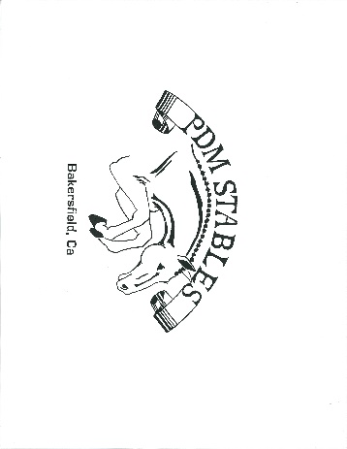
SPONSORSHIP
OPPORTUNITIES
Platinum Series – Four divisions ($1,000)
Recognition in all Public Announcements
Preferred placement of a full page advertisement in the event premium
Large Prominent signage the day of each event
Company logo published in all event series premiums
Premiere name recognition at the awards banquet with four division awards
Large logo printed on a competition jump
Gold Series – Three divisions ($750)
Recognition in all Public Announcements
Preferred placement of a full page advertisement in the event premium
Prominent signage the day of each event
Company logo published in all event series premiums
Premiere name recognition at the awards banquet with three division awards
Silver Series – Two divisions ($500)
Recognition in all Public Announcements
Preferred placement of a 1/2 page advertisement in the event premium
Company logo published in all event series premiums
Signage the day of each event
Premiere name recognition at the awards banquet with two division awards
Basic Series – One division ($250)
Recognition in all Public Announcements
Preferred placement of a 1/4 page advertisement in the event premium
Company logo published in all event series premiums
Signage the day of each event
Premiere name recognition at the awards banquet with one division award

SPONSORSHIP
OPPORTUNITIES

Please make sponsorship checks payable to PDM Stables

Company: .

Contact Name: .

Address: City Zip .

Phone: Fax: .

E-Mail: .

Please send this form, digital file of company logo and sponsorship check to:

PDM Stables
7500 Muller Road
Bakersfield, Ca. 93307
pdmstables@sbcglobal.net

